Case Study 1: Core Banking System (Monolithic + On-Prem)
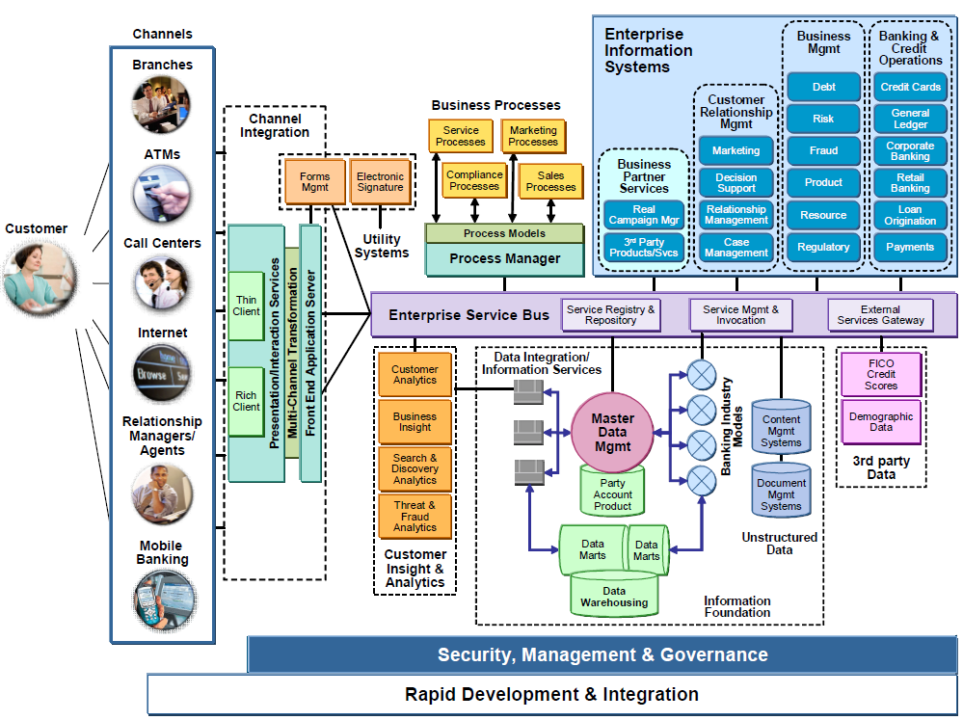
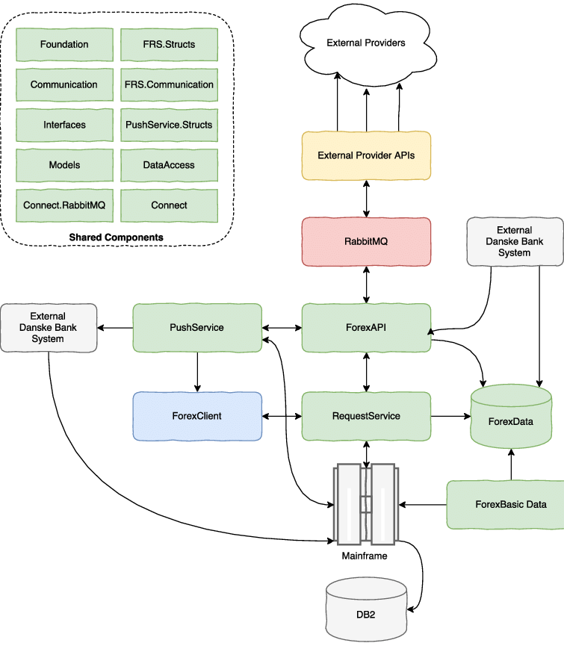
Company Context
- Large private bank
- Backend built 15+ years ago
- Runs on on-premise servers
- Java + Oracle DB
- Deployed as a single monolithic application

Architecture Reality
core-banking.war
├── Account Management
├── Transactions
├── Loans
├── Interest Calculation
├── Reporting
- One deployment
- One database
- One failure → entire bank impacted

Observations
Bottlenecks
- Shared db schema
- Tight coupling
- No automated test coverage
- Database performance
- Zero tolerance for downtime

